How to load the latest website changes.
- Clone the GitHub Repo - https://github.com/DataBytes-Organisation/DiscountMate_new
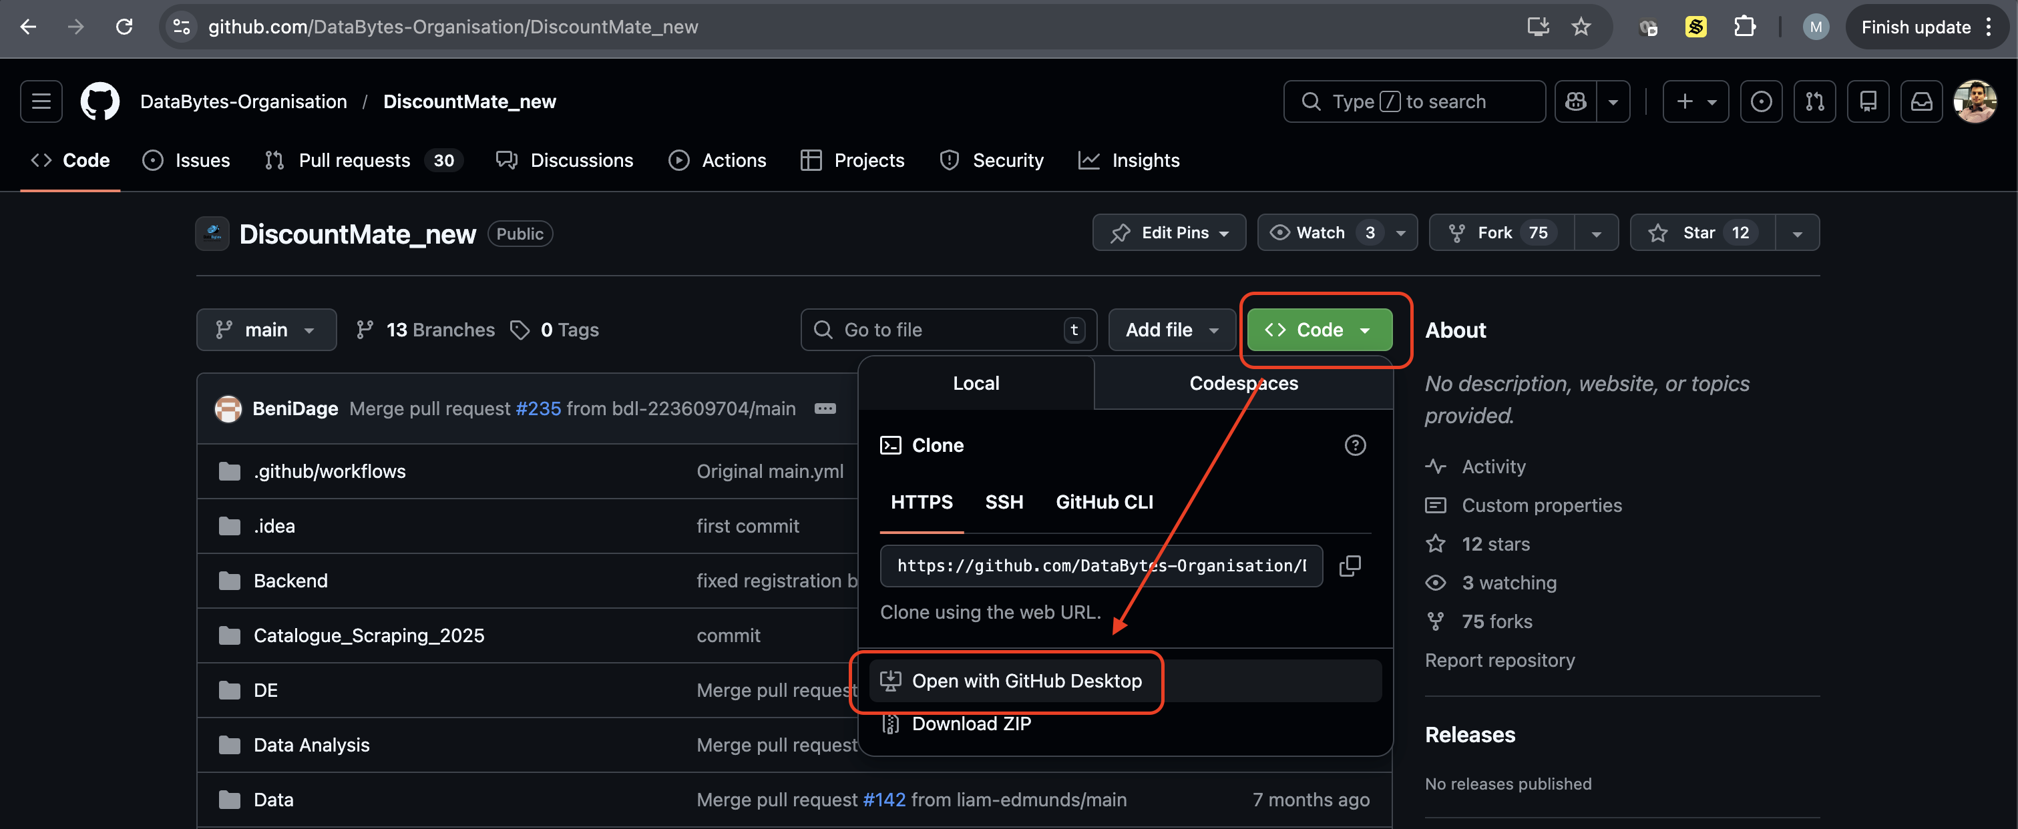

- In GitHub Desktop – Click ‘Fetch origin’
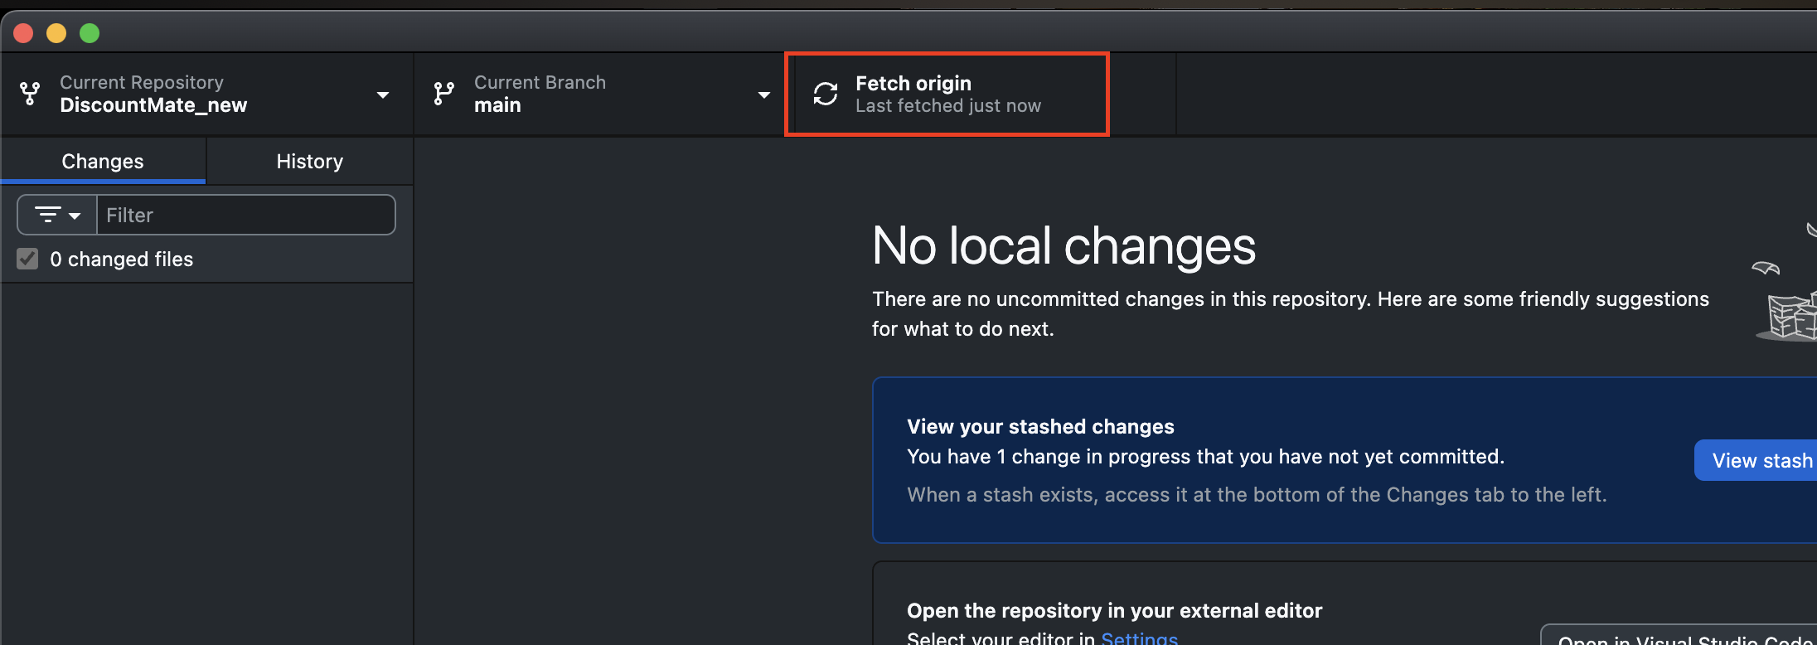

- Check you are on the main branch
  - Click main branch to swap branches
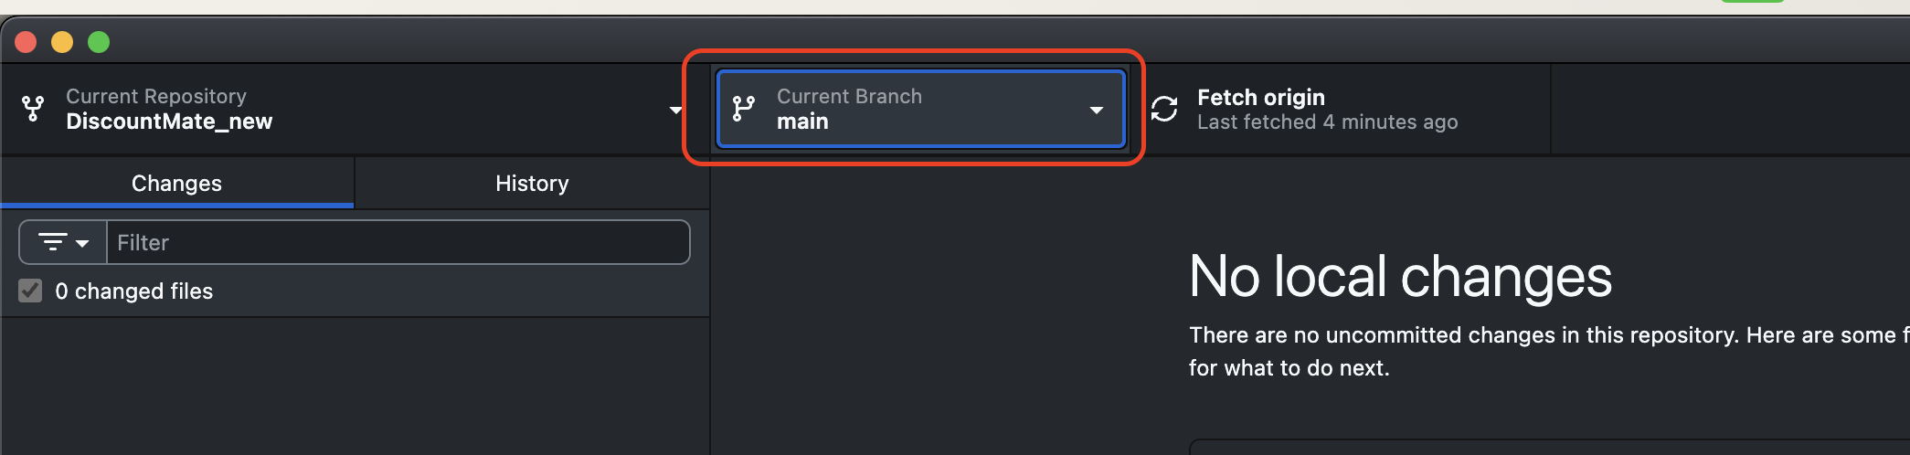
Once this loads, then navigate to BACKEND Folder in Terminal
- Run ‘NPM install’
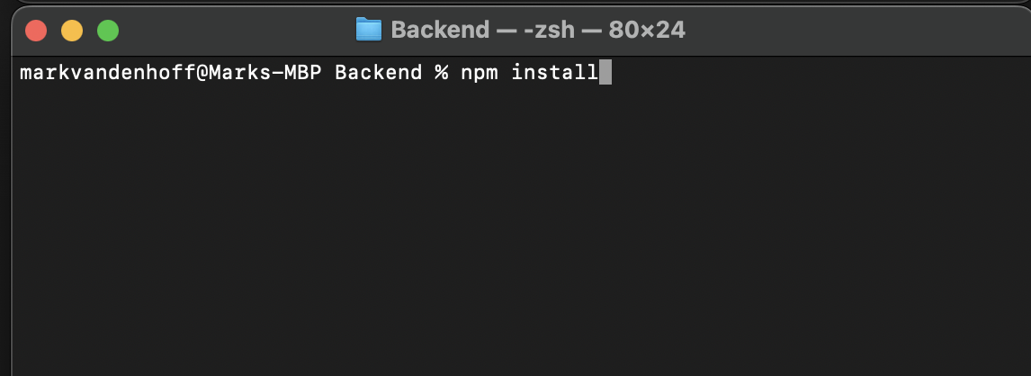
- Then run ‘NPM start’ (this should start the backend)
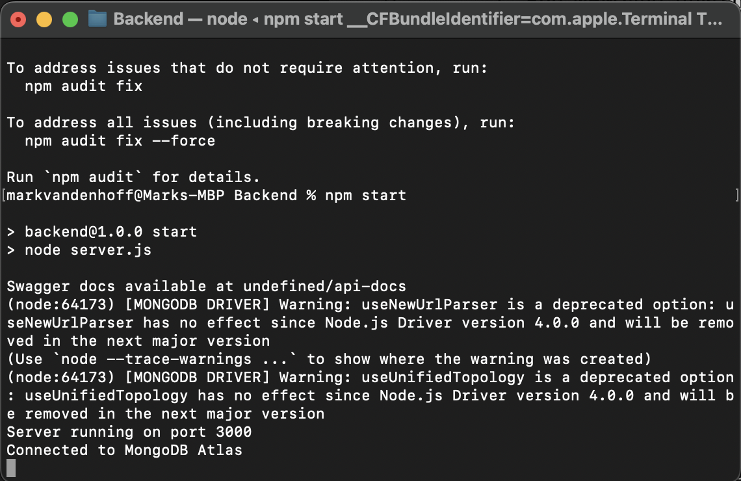

OPEN a new terminal window and navigate to FRONTEND FOLDER
- Run ‘NPM install’
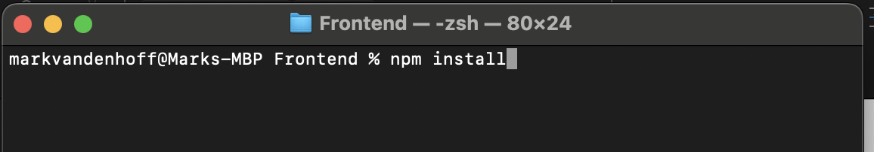
- Run ‘NPM expo start’
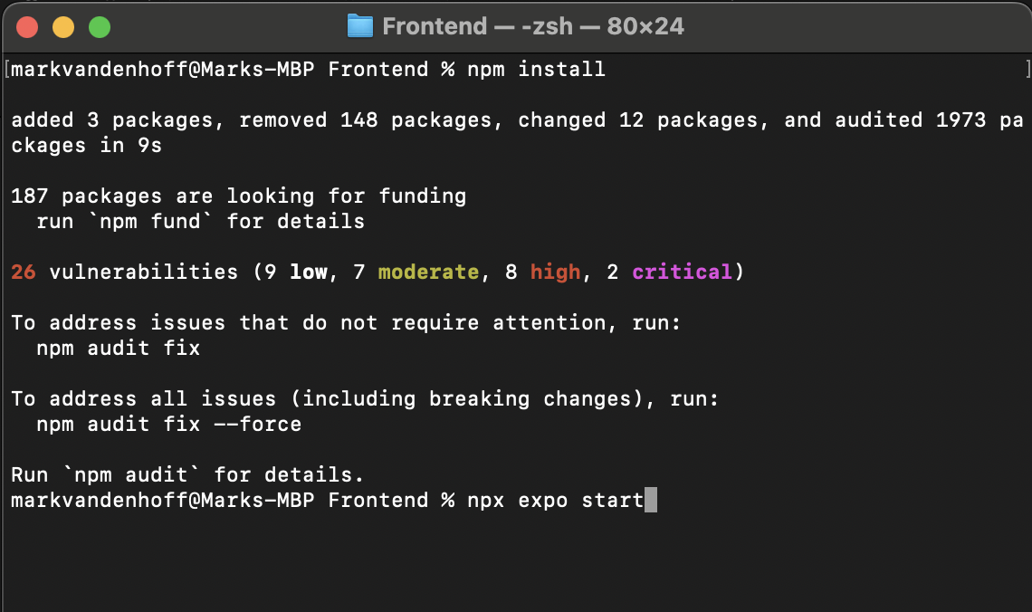
- The FRONTEND should be running now
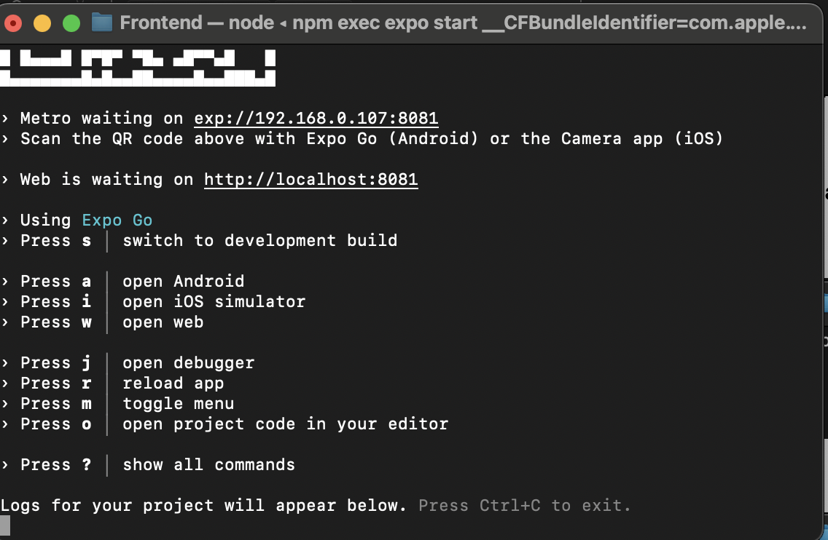
Open Browser and go to ‘LOCALHOST:8081’
